Abstract

Evidence of publication of Android app to Google Play Store

Evidence of publish

BIRDSCAPE – OPSC7312

Jordan Green, Daylin Shadrach, Mishra Mohammad, Cameron Pillay

**Step 1:**

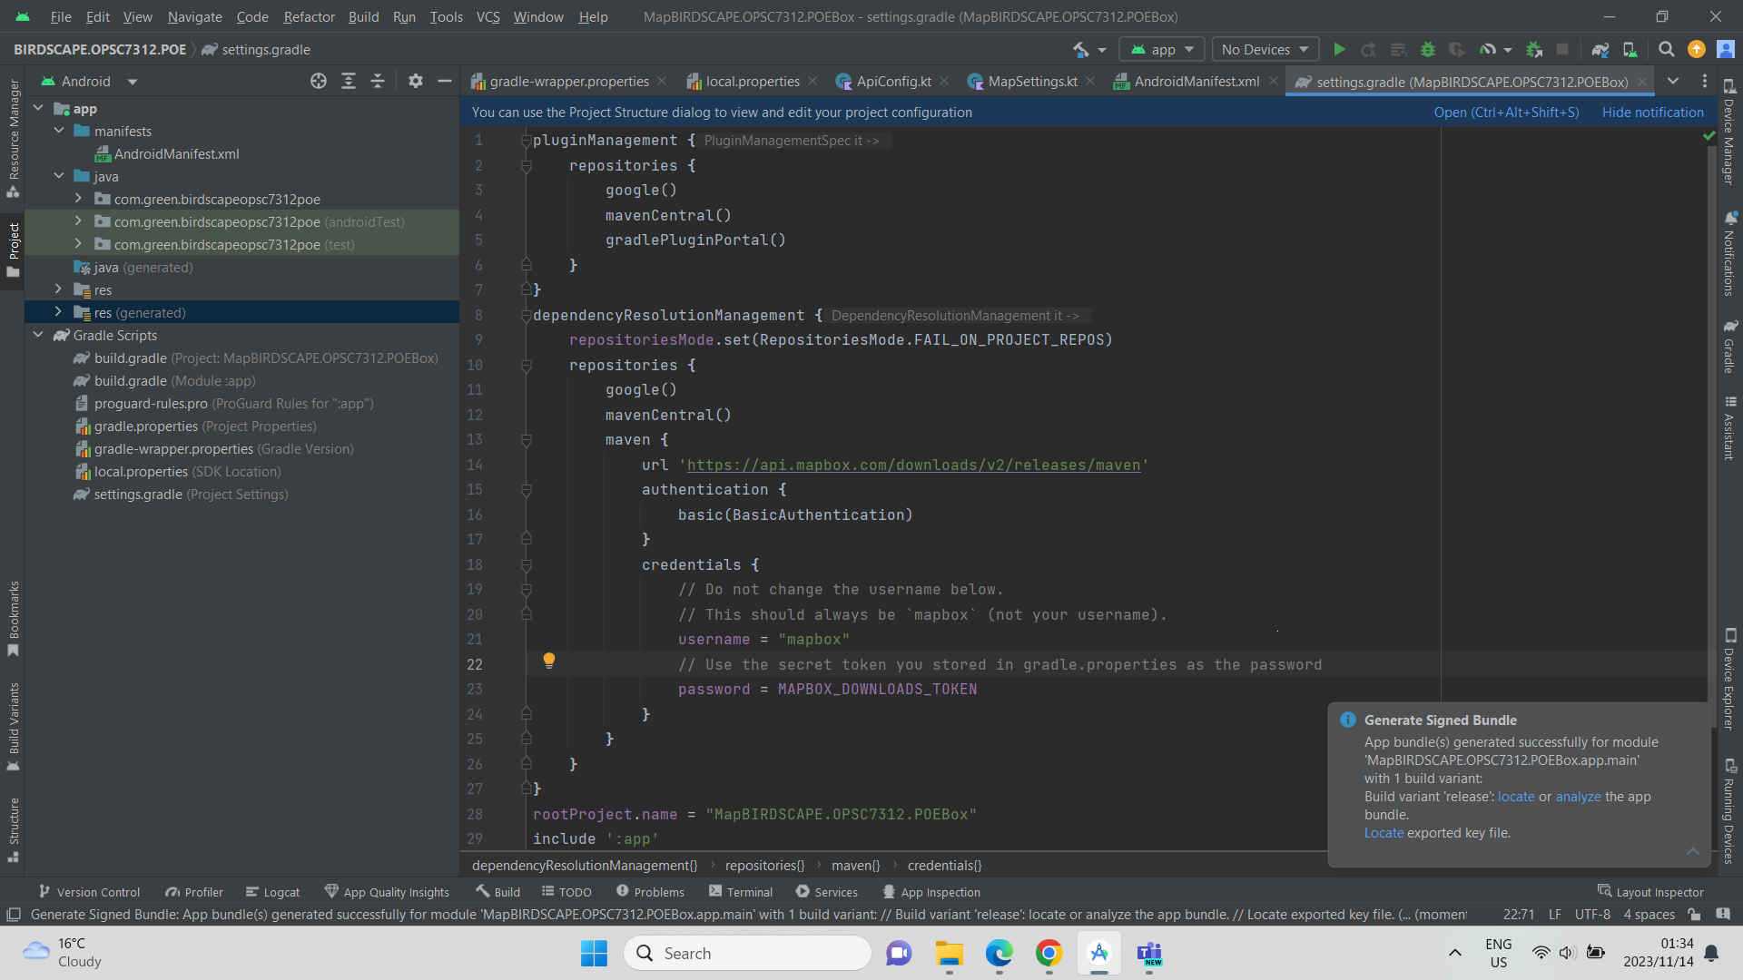

App bundle successfully generated in Android Studio. This creates an “*app-release.aab*” file which is uploaded onto Play Console.

**Step 2:**

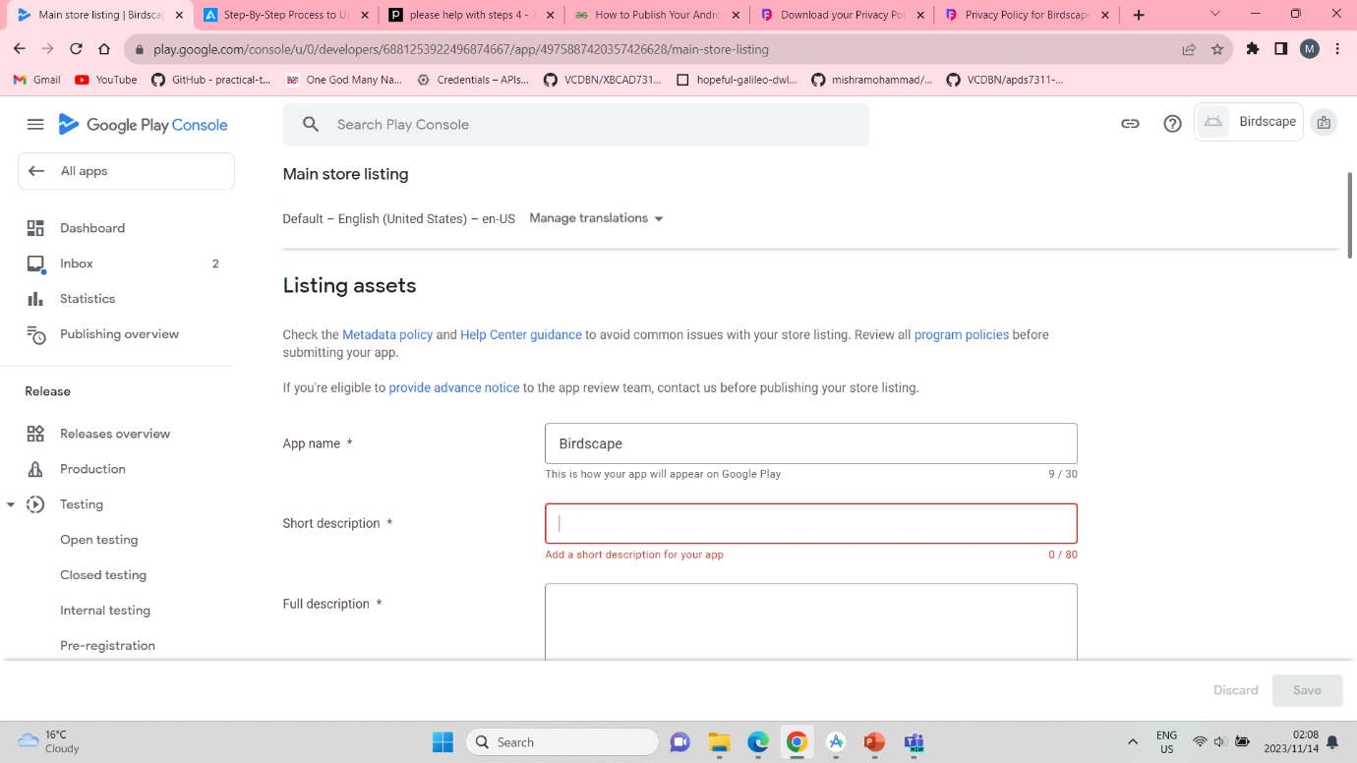

Create the app in Play Console and fill out required details in the ‘Store Listing’ section. This creates the app in Google Play.

**Step 3:**

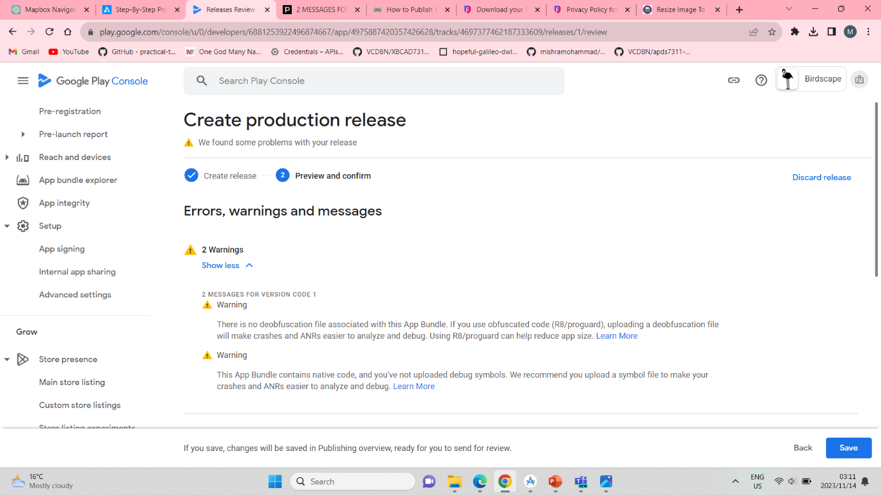Created a release and sorted errors and warnings that needed attention.

**Step 4:**

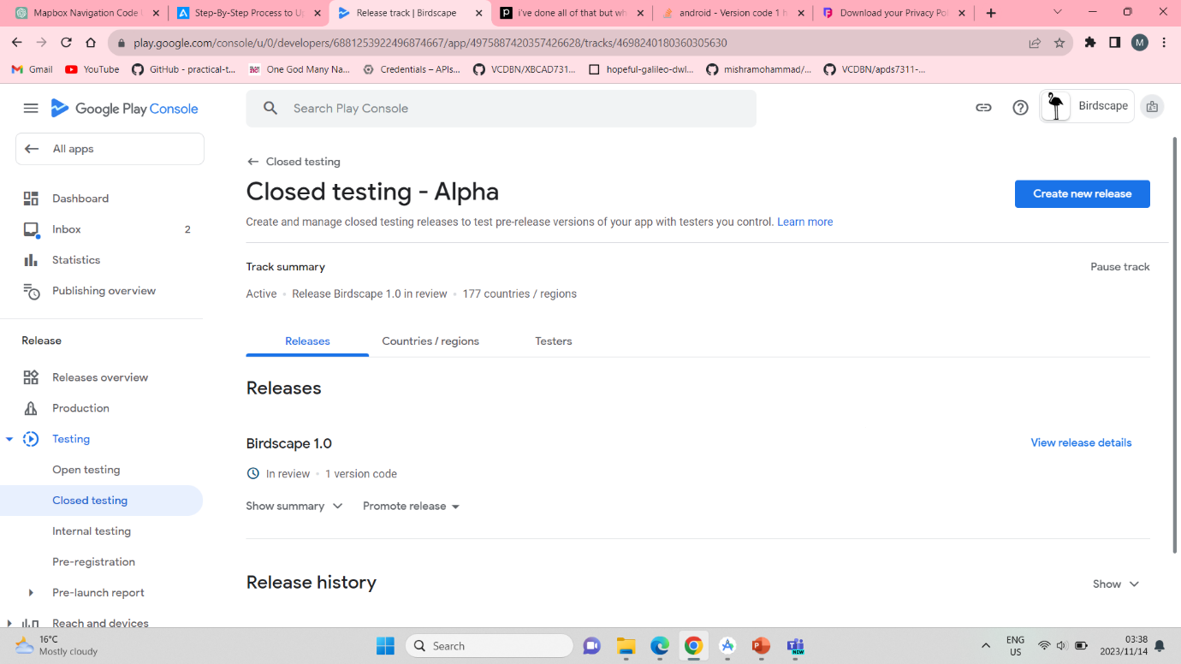

**Step 5:**

The Production tab indicates the activity status of the app and allows to track activities.

**Step 6:**

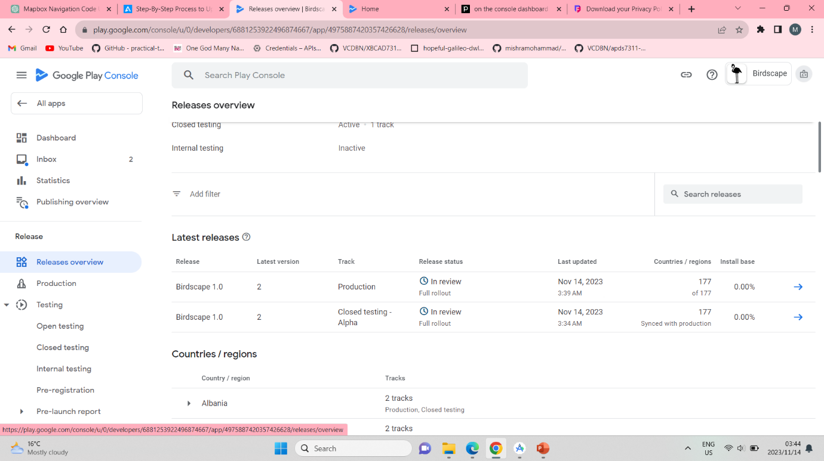

Release Overview

**Step 7:**

App “In-review” status which means it has been sent to Google for reviews and based on the feedback received, the app will either be rejected or published.

**References:**

Sharma, A. 2023. How to upload an app to google play store, *appinventiv*, 13 June 2023. [Blog]. Available at: <https://appinventiv.com/blog/how-to-submit-app-to-google-play-store/> [Accessed: 14 November 2023].